EXPERT SYSTEM FOR PRESCRIBING MEDICINE FOR GIVEN SYMPTOMS

**1.PROBLEM STATEMENT:**

The project is mainly focused on medical field in expert system where the person or patient login to the system and must select what are the symptoms for him that field information will be given to expert system. Expert system will diagonise what type of disease using medical database. The medical database will get all the information about medicine from pharmacy module and generate the prescription for the right symptoms and it gives to expert system.The medical database gives types of disease information to expert system.

**2.OVERALL DESCRIPTION:**

**2.1 MODULES**:

* Symptoms
* Expert System
* Medical DB
* Prescription
* Pharmacy

**2.2 MODULE DELIVERABLES:**

**SYMPTOMS:**

Basic Flow:

Patient must enter the symptoms that occurs for him. The symptoms must be exact so that it can be verified.

Alternate Flow:

If there are 4 symptoms then the patient is having big problem disease so,exit. If there are more than 4 then it is a serious problem

Precondition:

All the symptoms related to the disease are entered. Patient must enter the symptoms that occurs correctly.

Postcondition:

If the symptoms are corresponding to particular disease they are entered in expert system.

**PRESCRIPTION:**

Basic Flow:

The medicine is prescribed based on the symptoms.Medical prescription is given by expert system.

Alternate Flow:

If medicine is not available then exit. If there is no medicine then it comes under stock unavailable condition so update information in medical DB.

Precondition:

If medicine is only available in pharmacy it will generate prescription.If medicine is not available then store the details in expert system.

Postcondition:

If medicine are prescribed it will give to patient. The patient then gets the prescribed medicine in the shop.

**PHARMACY:**

**Basic Flow:**

Based on disease it will give medicine. Pharmacy gets the disease of prescribed medicine from the expert system.

Alternate Flow:

If medicine are not available it will pass the information as no medicine available

Precondition:

If prescribed medicine is available in pharmacy expert system must generate the required code.

Postcondition:

If prescribed medicine is available in pharmacy then expert system must load the data that is available.

**EXPERT SYSTEM:**

Basic Flow:

It will get symptoms and information from medical database to diagonise disease

Alternate Flow:

If any of the condition fails then system will exit.

Precondition:

Medical database and symptoms of patient should be present

Postcondition:

Prescribe the medicine to the patient from expert system to the patient.

**MODEL DATABASE:**

Basic Flow:

Medical database contains the backup and additional details which is not there in expert system.

Alternate Flow:

If medical database from expert system is not validated in medical database then first we have to update them

Precondition:

Medical database must contain some basic medicine stored in the memory of the system or computer

Postcondition:

If the details which is not present in expert system contained in database then we can extract information.

**3.UML DIAGRAM:**

**3.1 Usecasediagram:**



**3.2 Class Diagram:**



**3.3 Activity Diagram:**



**3.4 Sequence Diagram:**



**3.5 Collaboration Diagram:**



**3.6 Component Diagram:**



**3.7 Deployment Diagram**



**4. DATABASE DESIGN**

Database Name: Medical

Table Name : Patient

|  |  |
| --- | --- |
| Fields | Data type |
| pid | Integer |
| pname | Text |
| age | Integer |
| gender | Text |
| symptoms | Text |
| drug | Text |

**5. IMPLEMENTATION:**

Form1 (Login form)

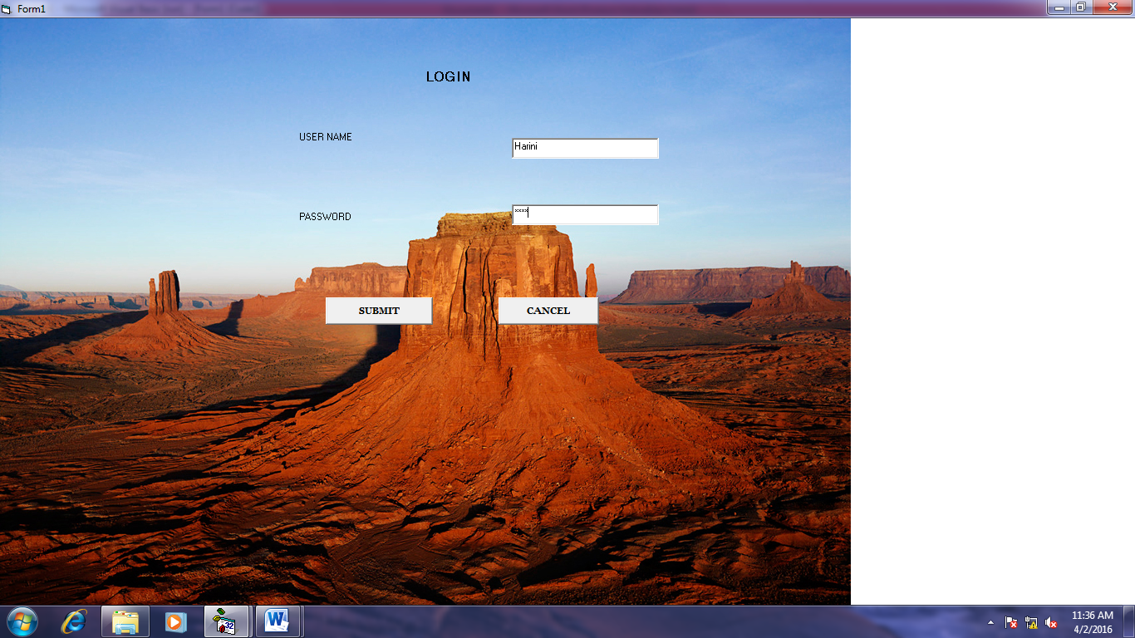

Coding:

Private Sub Command1_Click()

Form2.Show

End Sub

Private Sub Command2_Click()

End

End Sub

Form 2 (Main menu)

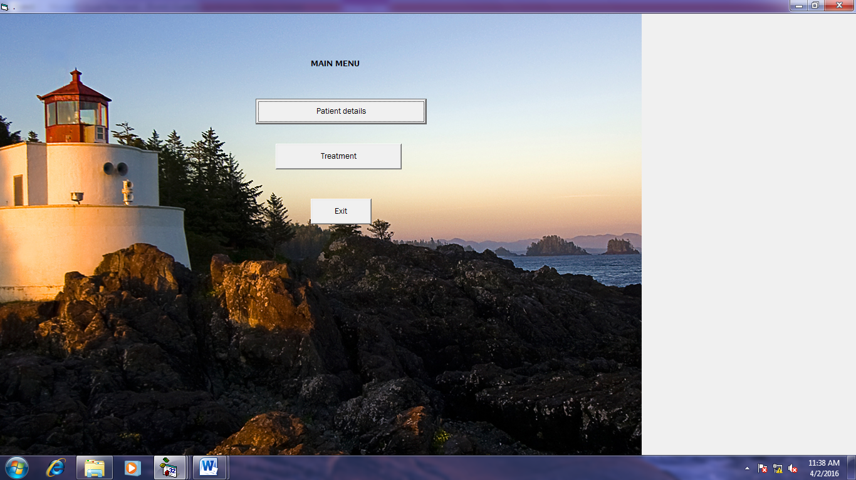

Coding:

Private Sub Command1_Click()

Form3.Show

End Sub

Private Sub Command2_Click()

Form4.Show

End Sub

Private Sub Command3_Click()

Form1.Show

End Sub

FORM 3 (Patient data entry)

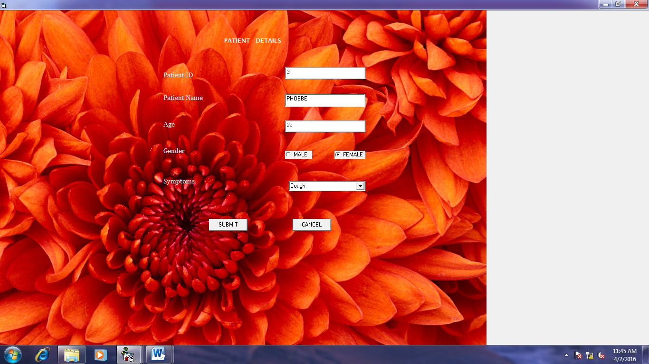

Coding:

Private Sub Command1_Click()

Data1.Recordset.AddNew

Data1.Recordset.Fields("pID") = Text1.Text

Data1.Recordset.Fields("pName") = Text2.Text

Data1.Recordset.Fields("age") = Text3.Text

If Option1.Value = True Then

Data1.Recordset.Fields("Gender") = "Male"

Else

Data1.Recordset.Fields("Gender") = "Female"

End If

Data1.Recordset.Fields("Symptoms") = Combo2.Text

Data1.Recordset.Update

MsgBox ("Data Added")

End Sub

Private Sub Command2_Click()

Form2.Show

End Sub

Private Sub Form_Load()

Combo2.AddItem ("Fever")

Combo2.AddItem ("Cough")

Combo2.AddItem ("Cold")

End Sub

FORM 4 (Prescription form)

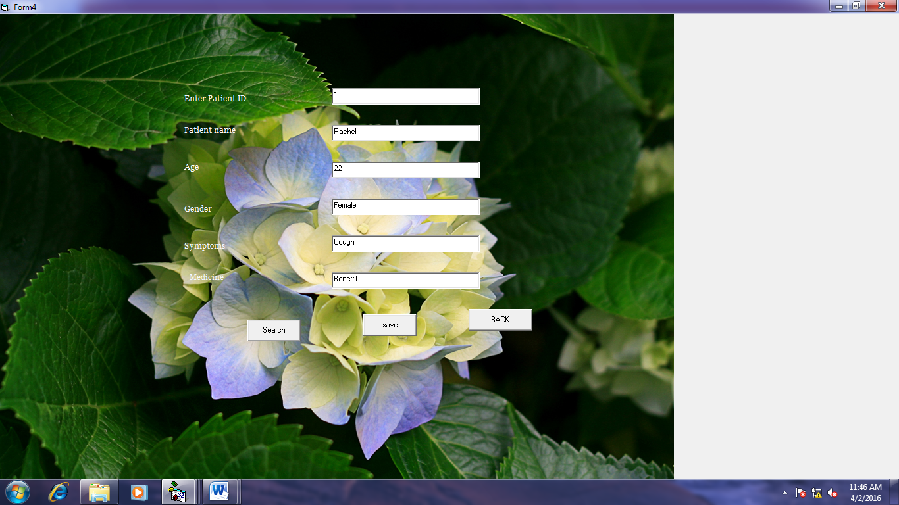

Coding:

Private Sub Command1_Click()

Data1.Recordset.Edit

Data1.Recordset.Fields("Drug") = drug.Text

Data1.Recordset.Update

MsgBox ("Data Added")

End Sub

Private Sub Command2_Click()

Form2.Show

End Sub

Private Sub Command3_Click()

Data1.Recordset.MoveFirst

Do While Not Data1.Recordset.EOF

If Data1.Recordset.Fields("pid") = pid.Text Then

pid.Text = Data1.Recordset.Fields("pid")

pname.Text = Data1.Recordset.Fields("pname")

age.Text = Data1.Recordset.Fields("age")

gender.Text = Data1.Recordset.Fields("Gender")

symptoms.Text = Data1.Recordset.Fields("Symptoms")

GoTo out

End If

Data1.Recordset.MoveNext

Loop

MsgBox ("not found")

out:

End Sub

**6.TESTING:**

|  |  |  |  |  |  |
| --- | --- | --- | --- | --- | --- |
| **Test case ID: Test_01** | | | | | |
| Test priority  (Low/Medium/High):Medium | | | | | |
| Module name: login | | | | | |
| Test title :verify login with valid username and password | | | | | |
| Precondition: user has invalid username and password | | | | | |
| S.NO | TEST STEPS | EXPECTED  RESULTS | ACTUAL  RESULTS | STATUS | NOTES |
| 1 | Provide valid  User name | User should  Be able to  login | The user is able to move to next  Entry | Success | - |
| 2 | Provide valid password | User should be  Able to  Login | The user is able  To login  Successfully | Success | Incase of wrong  Password was given an error  Message box was  displayed |
| 3 | Click login | User should be able to navigate to next page after validation | User name and password is validated and next page is displayed | Success | Incase user gives wrong entry the sign in page remains active |
| 4 | Click signup | User should be able to navigate to next page where user enters his credentials | User navigates to the signup page where his user name and password is validated | success | - |

**RESULT:**

The Expert system to prescribe the medicines for the given symptoms was designed and implemented successfully.